Name | : | Dr. Ankita Upadhya | 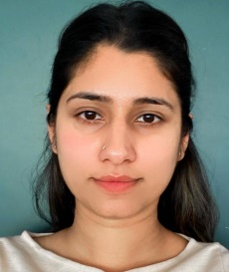
Designation | : | Assistant Professor (Contr.)
Contact Address | : | Division of Basic Engineering and Sciences  Faculty of Agricultural Engineering SKUAST-J Main Campus, Chatha, Jammu-180009 (J & K)
Area of Specialization | : | Civil Engineering
Research interest | : | - Highway Engineering  - Transportation Engineering  - Material Engineering  - Green Materials and Infrastructure  - Green Buildings  - Soft Computing
Contact |  | 9682163745

